**DAILY ONLINE ACTIVITIES SUMMARY**

|  |  |  |  |  |  |  |  |  |
| --- | --- | --- | --- | --- | --- | --- | --- | --- |
| **Date:** | **13-06-2020** | | | | | **Name:** | **Ajeyashree K** | |
| **Sem & Sec** | **6th&A** | | | | | **USN:** | **4AL17CS002** | |
| **Online Test Summary** | | | | | | | | |
| **Subject** | | **Python Application Programming.** | | | | | | |
| **Max. Marks** | | **30** | | **Score** | | | **21** | |
| **Certification Course Summary** | | | | | | | | |
| **Course** | **INTRODUCTION TO FULL STACK DEVELOPMENT.** | | | | | | | |
| **Certificate Provider** | | | Greatlearning  Academy | | **Duration** | | | 20hours |
| **Coding Challenges** | | | | | | | | |
| **Problem Statement:**1 Write a C Program to calculate Electricity Bill.  2. How to find the first non repeated character of a given String.  3. Write a Java Program to determine whether a given matrix is a sparse matrix.  4. Python Program to print the pattern. . | | | | | | | | |
| **Status: Done** | | | | | | | | |
| **Uploaded the report in Github** | | | | | **YES** | | | |
| **If yes Repository name** | | | | | <https://github.com/Ajeyashree/19-5-2020-online-coding-activity> | | | |
| **Uploaded the report in slack** | | | | | **YES** | | | |

Online Test Details:

Subject:- **Python Application Programming.**

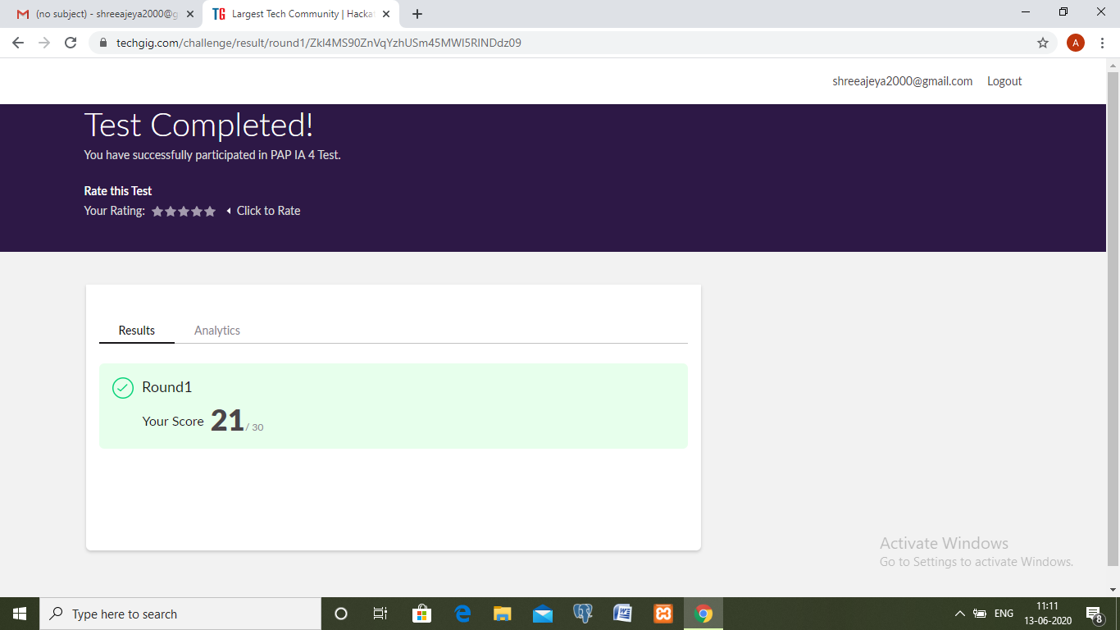

Certification Course Details:

**INTRODUCTION TO FULL STACK DEVELOPMENT.**

Today I have studied :

* Type, ID and class selector.
* Attribute selector.
* Attribute + value selector.
* Pseudo class selector.
* Hover Pseudo class selector.
* Link, Active and Visited.
* Preference order.
* Structural Pseudo Classes.

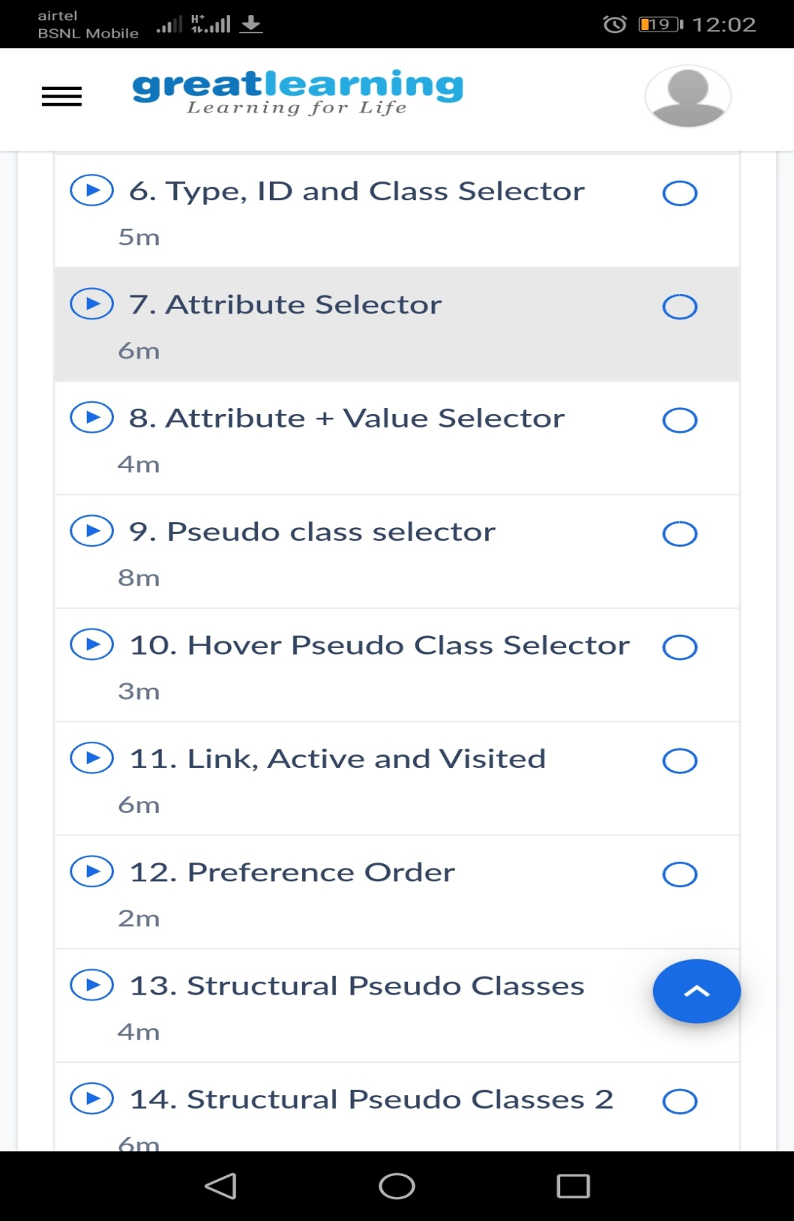

Coding Challenges Details:

1.Write a C Program to calculate Electricity Bill

Given an integer U denoting the amount of KWh units of electricity consumed, the task is to calculate the electricity bill with the help of the below charges:  
• 1 to 100 units – Rs. 10/- Per Unit  
• 100 to 200 units – Rs. 15/- Per Unit  
• 200 to 300 units – Rs. 20/- Per Unit  
• above 300 units – Rs. 25/- Per Unit

Examples:

Input: U = 250

Output: 3500

Explanation:

Charge for the first 100 units – 10100 = 1000Charge for the 100 to 200 units – 15100 = 1500  
Charge for the 200 to 250 units – 20*50 = 1000  
Total Electricity Bill = 1000 + 1500 + 1000 = 3500

#include <stdio.h>

#include <stdlib.h>

int main()

{

int unit;

printf("U=");

scanf("%d",&unit);

if(unit<=100){

printf("%d",unit*10);

}

else if(unit<=200){

printf("%d",(100*5)+(unit-100)*15);

}

else if(unit<=300){

printf("%d",(100*10)+(100*15)+(unit-200)*20);

}

else if(unit>300){

printf("%d",(100*10)+(100*15)+(100*20)+(unit-300)*25);

}

else{

printf("No value");

}

getch();

return 0;

}

**Output:**

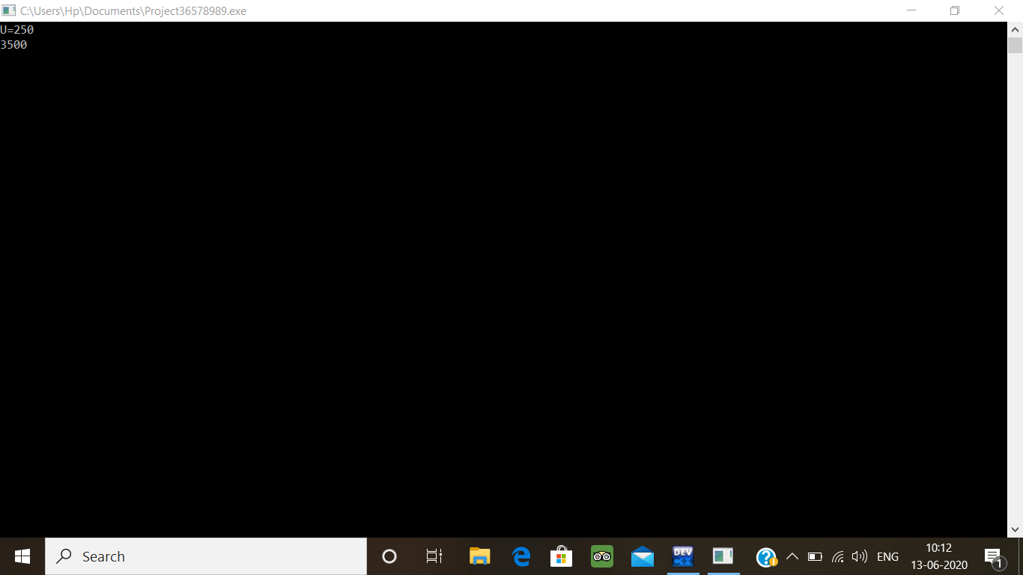

2. How to find the first non repeated character of a given String?

import java.util.*;

public class Main {

public static void main(String[] args) {

String str1 = "gibblegabbler";

System.out.println("The given string is: " + str1);

for (int i = 0; i < str1.length(); i++) {

boolean unique = true;

for (int j = 0; j < str1.length(); j++) {

if (i != j && str1.charAt(i) == str1.charAt(j)) {

unique = false;

break;

}

}

if (unique) {

System.out.println("The first non repeated character in String is: " + str1.charAt(i));

break;

}

}

}

}

**Output:**

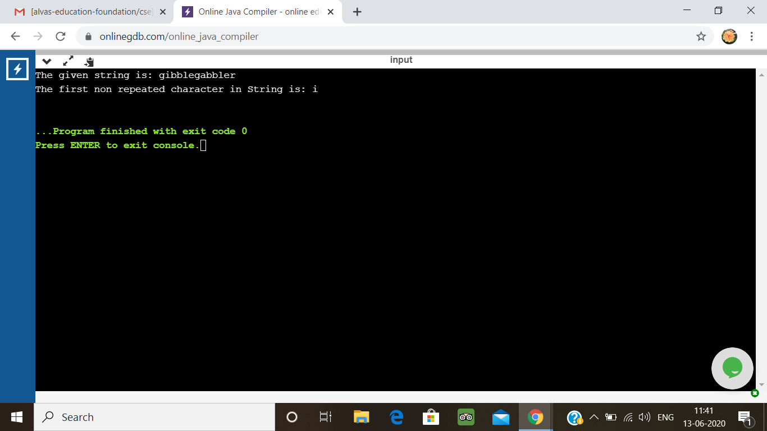

3. Write a Java Program to determine whether a given matrix is a sparse matrix

Description:  
Algorithm  
STEP 1: START  
STEP 2: DEFINE rows, cols, size  
STEP 3: SET count = 0  
STEP 4: INITIALIZE first matrix a[][] ={{4,0,0}, {0,5,0}, {0,0,6}}  
STEP 5: rows = a.length  
STEP 6: cols = a[0].length  
STEP 7: size = rows*cols  
STEP 8: REPEAT STEP 9 to STEP 10 UNTIL i<rows  
//for(i=0;i<rows; i++)  
STEP 9: REPEAT STEP 10 UNTIL j<cols  
//for(j=0;j<cols; j++)  
STEP 10: if(a[i][j]==0) then count++  
STEP 11: if(count>size/2) then PRINT "Yes" else PRINT "No"  
STEP 12: END

public class Main

{

public static void main(String[] args) {

int rows, cols, size, count = 0;

int a[][] = {

{4, 0, 0},

{0, 5, 0},

{0, 0, 6}

};

rows = a.length;

cols = a[0].length;

size = rows * cols;

for(int i = 0; i < rows; i++){

for(int j = 0; j < cols; j++){

if(a[i][j] == 0)

count++;

}

}

if(count > (size/2))

System.out.println("Given matrix is a sparse matrix");

else

System.out.println("Given matrix is not a sparse matrix");

}

}

**Output:**

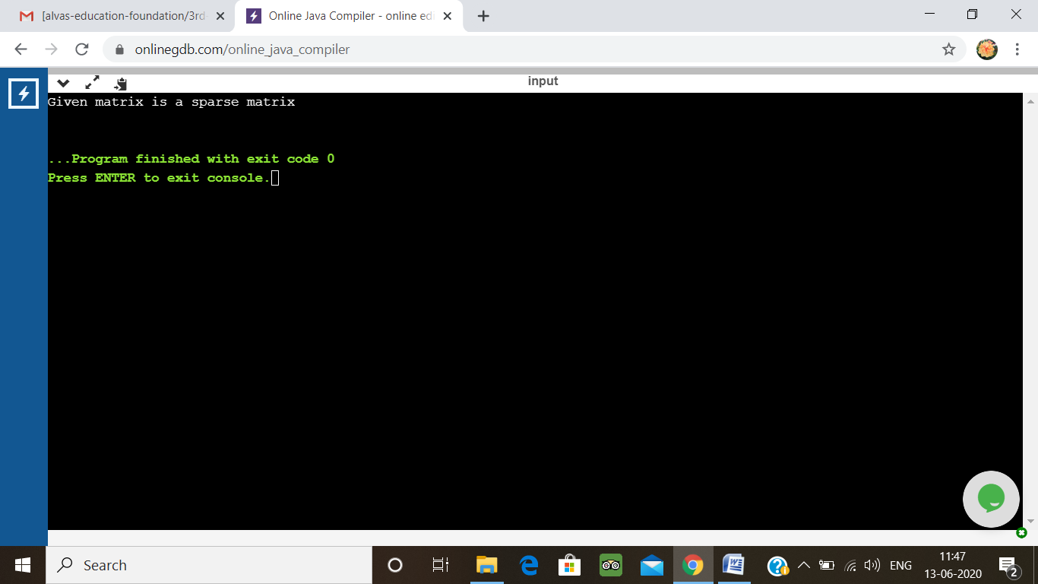

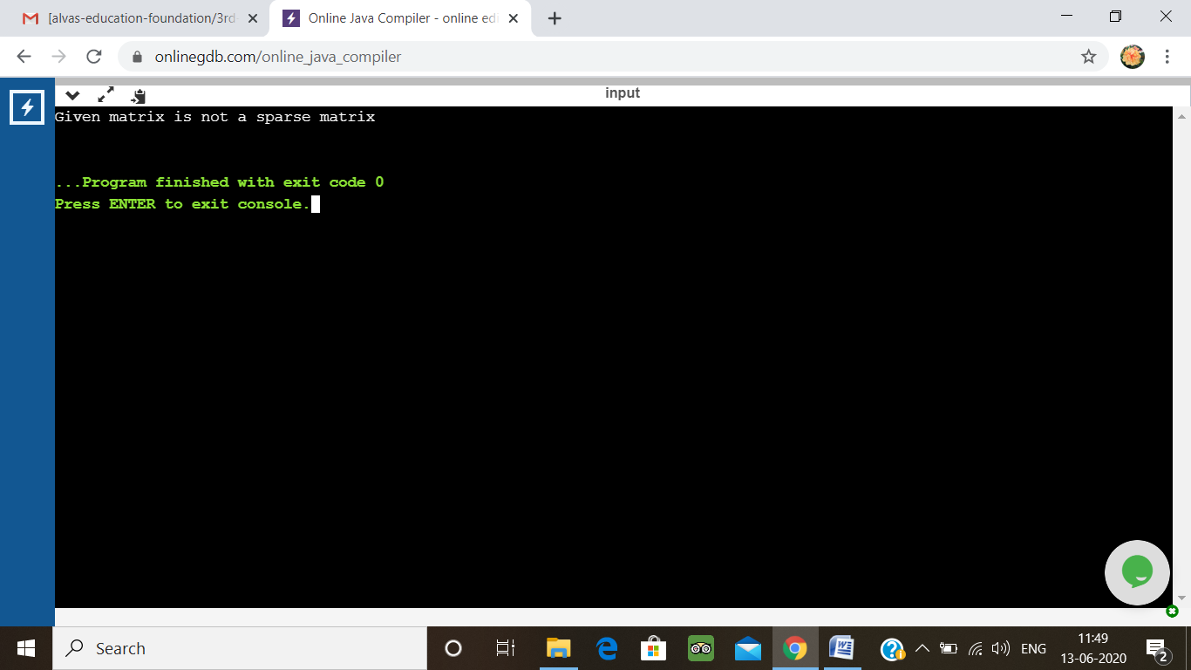

4.Python Program to print the pattern

Description:  
Input:  
Number of rows is 5

Output Pattern is:  
A  
B C  
D E F  
G H I J  
K L M N O

def contalpha(n):

num = 65

for i in range(0, n):

for j in range(0, i+1):

ch = chr(num)

print(ch, end=" ")

num = num +1

print("\r")

n = 5

contalpha(n)

**output:**

